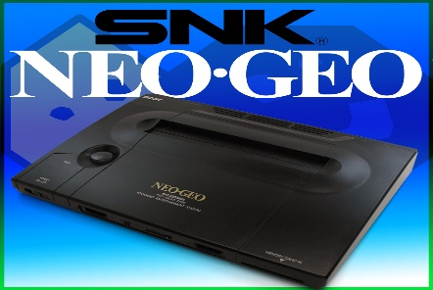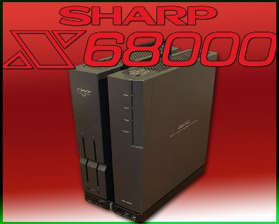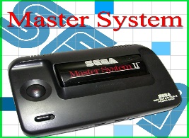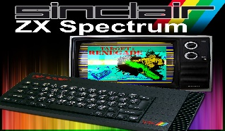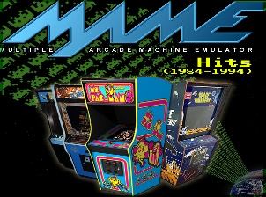***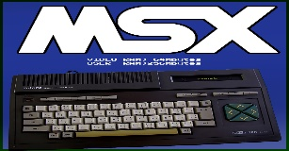*****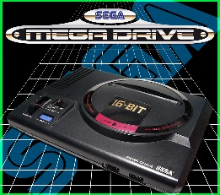**

 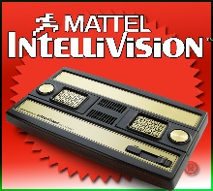 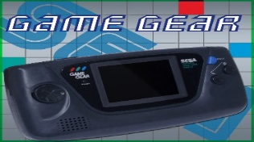

***Romsets &*** XBOX ***Emulators in File Explorer***

***By* Xm-ulation**

*When accessing the massive amount of Emulators, you can do this this via “****File Explorer” on the UnleashX dashboard*** *submenu (this is the first screen that loads up) –* ***or via the*** *“****EMULATORS” option on the same submenu on the dashboard****. It is much easier to load them from the dashboard menu however, a lot of them will appear as the Emulator’s name and not the console or computer it represents. Loading them from the list in File Explorer can be more helpful in the beginning, as we have labelled each Emulator with its associated console beside it, i.e., “****Surreal 64 – Nintendo 64 Emulator****”. Below are the Instructions to access the Emulators using the* ***“FILE EXPLORER”*** *method. Please note that you can add to the Emulators, however you must keep available free space above 0% or your Emulators will not load.* **TO LOAD ANY EMULATOR IN FILE EXPLORER, YOU MUST SELECT THE FILE “*DEFAULT.XBE*” FIRST, USING THE “A” OR GREEN BUTTON. THIS BOOTS THE EMULATOR PROGRAM AUTOMATICALLY. FOR EXAMPLE, IN FILE EXPLORER : SELECT “F” > SELECT EMULATORS > SELECT “AMIGA Emulator” folder > SELECT “default.xbe”. DON’T FORGET, THE ROMS ARE SITUATED IN THE “F” DRIVE, THEREFORE IF AN EMULATOR HAS SELECTED “D” AS THE DEFAULT DRIVE, YOU MUST CHANGE THEIR LOCATION TO “F” AT THE SEARCH SCREEN – USE THE YELLOW OR “Y” BUTTON TO BRING YOU BACK TO THE LETTERED DRIVES E,F,G .**

***FOUND IN F and G DRIVES(if the hdd is over 500gb), For Example, F:/ DRIVE >Emulators > Select Emulator – Select the “default.xbe” file to launch Emulator(s).***

**7 *Applications added - accessed via Applications on the main (UnleashX) dashboard –*** *this includes* ***XBMC-Emustation****,* ***DVD2XBOX*** *(for adding games & movie dvds to the hard drive) and* ***Chimp*** *(this program is used if you are swapping your hard drive to a bigger capacity –* ***use at your own risk!****).* ***DVD-X2*** *is also essential for watching DVD movies, you need to launch this App first before you can watch a DVD.*

***100+ Dashboard Skins added – accessed through the main dashboard under “SKINS”***

***140+ Original unreleased Ported Games - accessed via “GAMES” on the main dashboard***

***50+ Official XBOX Games accessed via “GAMES” on the main dashboard menu (bottom left of screen) and VIA COINOPS8/NINJA PREMIUM (console systems>Xbox).***

***Attention – Please do not select the option to “REBOOT” your XBOX, from the main menu on the dashboard that first loads up (UNLEASHX). Your Modfather could be hard-modded with a mod-chip – selecting Reboot will cause the Xbox to reload with an error message. The option is designed for soft-modded Xbox’s only and does not work with the hard-modded ones. If you need to Reboot, simply select the “Shutdown Xbox” option and switch it back on manually – if an error message appears.***

***\*To exit all of the Emulators, instead of switching off the XBOX, you simply hold in the left and right trigger buttons and press the Start and Select buttons simultaneously.***

***To exit any game and return to the game section screen in: COINOPS, PREMIUM NINJA, HYPERVISION – hold in the START & BACK buttons on your controller. To save your game position or load one, you hold in the BACK button and the small WHITE or BLACK button. A message will appear at the top left of the screen to confirm the state had been saved/loaded.***

30+ **NEC PC-98** – Emulator **NEKO PROJECTX_NEC PC 98 EMU** > roms are in the ***roms*** folder

700+ **MGT Same Coupé** – Emulator **SAMX** > roms are in the ***ROMS*** folder

47 **SuperVision** – Emulator name **SuperVision Emu** > roms are in the ***svroms*** folder

3600+ **Kawa**– Emulator name **Kawa_Arcade & NeoGeo** > roms are in the ***roms*** folder

48 **Chip8** – Emulator **CHIP8 Emu** > roms are in the ***chip8roms*** folder

54 **Vectrex** – Emulator **XVectrex_Vectrex Emu**> roms are in the ***roms*** fo0lder

24 **Virtual Boy** – Emulator **Virtual BoyX _VirtualBoy Emu** > roms are in the ***vbroms*** folder

|  |
| --- |
| 1420+ **GameBoy** |
| 1500+ **GameBoy Colour** Emulator **XBoyAdvance_GameBoy & GBA EMU** |
| 800+ **GBA** – *now in Ninja Premium* All roms in the ***gbaroms*** folder.  930+ **Gameboy & GameBoy Colour -**  **Fullset of Japanese roms** |

8 **CPS 3** – Emulator**CPX3 – CPS3_Capcom Games *>*** roms are in the ***roms*** folder

900+ **Sharp X68000** – ***found in COINOPS 8***

300 **Atari Lynx *–*** Emulator **Lynxbox_AtariLynx** > roms are in the ***lynxroms*** folder

800+ **MSX & MSX 2 *– found in NINJA PREMIUM > CONSOLE SYSTEMS***

800+ **TurboGrafx (PC Engine)** 6 **Supergrafx** – *now in Ninja Premium*

150+ **Playstation One** – *Accessed in CoinOP8 and Ninja Premium*

500+ **Raine** (Arcade Games) – Emulator **XRaine_Arcade Games** > roms are in the ***roms*** folder

5000+ **COINOPS 8 MASSIVE (also contains about 100 PS1 games and some Original Xbox games such as HALO 1&2, BLACK & HOUSE OF THE DEAD III)** - load from ***main dashboard menu***

13500+ **NINJA PREMIUM** – load from ***main dashboard menu***

***includes the full set of games for SEGA MEGADRIVE/GENESIS, SEGA 32X, SEGA GAME GEAR, SEGA MASTER SYSTEM, NINTENDO ENTERTAINMENT SYSTEM (NES), SUPER NINTENDO (SNES), PS1 GAMES AND 32 ORIGINAL XBOX GAMES HAVE BEEN ADDED – DON’T MISS THIS INCREDIBLE FRONT-END! MOST OF YOUR XBOX GAME REQUESTS ARE IN THIS ADDON, GO TO THE SECTION – “CONSOLE SYSTEMS”>FOLLOWED BY “XBOX”***

3600+ **Final Burn Legends 1.23** – Same Emulator > roms are in the ***roms*** folder

6000+ **ZX Spectrum** – Emulator **DidntXpectrum** > roms are in ***specgames*** folder

6000+ **Spectrum 128** – Emulator **DidntXpectrum** > roms are in ***specgames*** folder

40,000+ **Amstrad CPC** – Emulator **ArnoldX_Amstrad_CPC** > roms are in the ***CPCROMS*** > ***Amstrad CPC Roms CWG folder***

210 **Colecovision** – Emulator **Koleko-x_Colecovision** > roms are in the ***Roms*** folder

170+ **Intellivison** – Emulator **BlissX_Intellivison** > roms are in the ***Roms*** folder

350+ **Nintendo 64** – Emulator **Surreal_64_Nintendo64** (**\*see note below**) > roms are in ***Roms*** folder

***\*There are three Emulators built into the Surreal 64 addon, this is to give all the games a better chance to run as perfectly as possible. There is a comment box at the bottom of the screen for each game – this gives you information on which emulator the game works with best. After you select the game it will ask you to choose which emulator out of the three you would like to use, so therefore pick accordingly with the information given. The next screen after that it will ask you to pick the N64 graphics card (Rice) you would like to use (5.11, 6.0 etc). this is not overly crucial, however if you do find that there are some minor graphics glitches during gameplay – choose the next graphics card on the list, and so on. N64 emulation is not 100% perfect – however there is a big majority of these games that run brilliantly!***

1440**+ Nintendo Super Famicom** – Emulator **Zsnexbox_NintendoSuperFamicom >** roms are in the **SuperFamicomRoms** folder

1000+ **NES** (Full catalogue with mostly hacked and unreleased versions too) – Emulator **mednafenx_NES** > roms are in the ***nesroms*** folder

420+ **HyperVision 6** - Emulator **HyperVISION 6** > load from the ***UnleashX dashboard menu***

140+ **HyperVision NeoGeo Station Gems** > load from the ***UnleashX dashboard menu***

300+ **Sega Game Gear** – Emulator **SMSPlusX – Sega game Gear** > roms are in the ***ggroms***folder

600+ **Commodore Amiga** – Emulator **Amiga Emulator** > roms are in ***amigadisks*** folder

20000+ **Commodore 64** **–** Emulator **VICEX** > roms are in the ***c64disks*** folder

290+ **Commodore Vic 20** –Emulator **Vice20x_Vic20** > roms are in the ***vic20games*** folder

In all the computer based emulators like Amiga, Atari ST, Spectrum…when you have selected your game disk(s) into the respected disk drive(s) on screen, to load the game you hit the **B button** on your controller, this is the **RED** one. This is unusual as hitting the **B** button normally brings you back to the previous screen. In the case of the computer-based emulators though **B is to BOOT disk.**

60+ **SEGA SGS-1000 –** accessed in **NINJA PREMIUM > CONSOLE SYSTEMS**

300+ **Sega Game Gear** – Emulator **SMSPlusX – Sega game Gear** > roms are in the ***ggroms***folder

540+ **Sega Master System** – Emulator **MekaX_SegaMasterSystem** > roms are in the ***smsroms*** folder

38 **Sega 32 X**

940+ **Sega Megadrive/Genesis –**  Emulator **NeoGenesis_SegaEmulator >**

150+ **MEGA CD - *found in COINOPS 8*** all roms are in the ***sgenroms*** folder

6500+ **MAMEOxtras** (Arcade Games) – Emulator **MAME Plus** > roms are in the ***roms*** folder(s)

***To scroll down the MAME games list, you use the left & right trigger buttons***

***When the prompt to press “ok” comes on screen for MAME, simply move your left thumbstick in the direction of “left then right” reasonably quickly. This registers an ok and the console will load the game immediately. To insert a virtual coin to play a games, usually you press either the white button or the back button.***

2000+ **Atari ST** – Emulator **Atari ST Emu** > roms are in the ***MiscGames*** folder

3400+ **Atari 2600** - Emulator **Atari_2600 Emu** > roms are in the ***a26roms*** folder

900+ **Atari 800-5200** – Emulator **AtariXL & 800-5200 Emu** > roms are in the ***ataridisks*** folder.

265 **Atari XL** –Emulator **AtariXL & 800-5200 Emu**> roms are in the ***ataridisks*** folder

55 **Atari 7800** – Emulator **Atari_7800 Emu** > roms are in the ***Roms*** folder

130+ **Atari Jaguar** – Emulator **VirtualJaguarX_AtariJaguar** > roms are in the ***roms*** folder

**Killer Instinct 1 &** 2 – Emulator - **KixxEmulator_KillerInstinct1&2 –** load via the ***UnleashX dashboard menu***

340+ **Pocket Neo Geo** – Emulator **NeoPopX _PocketNeoGeo** > roms are in the ***ngpcroms*** folder

110+ **Wonderswan** – Emulator **WonderswanX_Wonderswan** > roms are in the ***wswanroms*** folder

1020+ **SNES** – Emulator **SNES9XBOX** > roms are in the ***snesroms*** folder

18 **SC3X** – Emulator **Sc3x_SegaSC3X** > roms are in the ***roms*** folder

8 **Pokemon** – Emulator **POKEMINI_Pokemon** > roms are in the ***roms*** folder

70+ **Odyssey** – Emulator **Odyssey** **Emu** > roms are in the ***O2roms*** folder

*After game has loaded you will be brought to a screen that says “****SELECT GAME****”. To launch the game you have chosen, simply bring up the virtual keyboard on-screen and hit the number “****1****” key.*

